Test Procedure:
- Physically install PXI –PCI controller card in one of PC’s PCI slot.
- Install all the modules in PXI chassis
- Connect Fiber Optic cable to PCI-PXI card and PXI-MXI card.
- It should display two LED for Power, Link (green colour) and Tx , Rx ( Yellow colour)
- Run ”NI Max”, to check the modules connected in the system. It will show as follows:
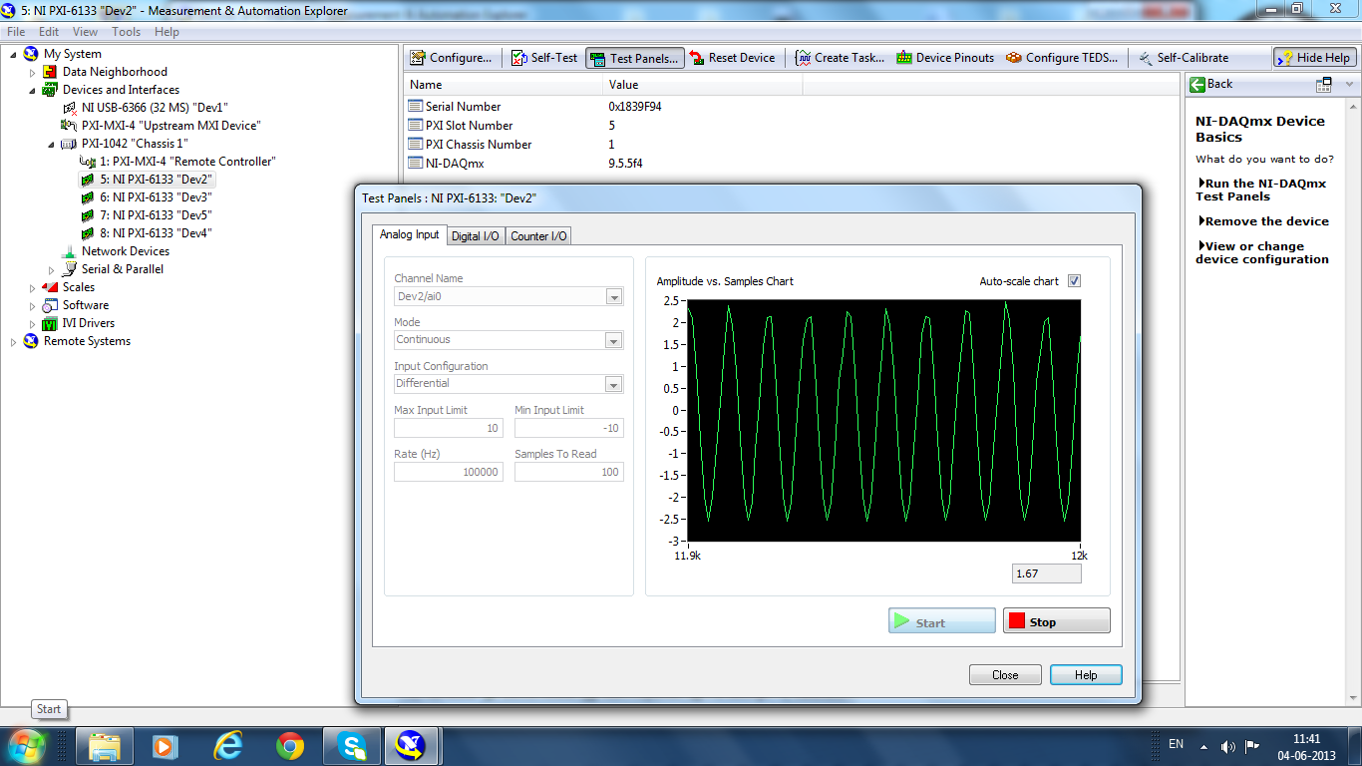

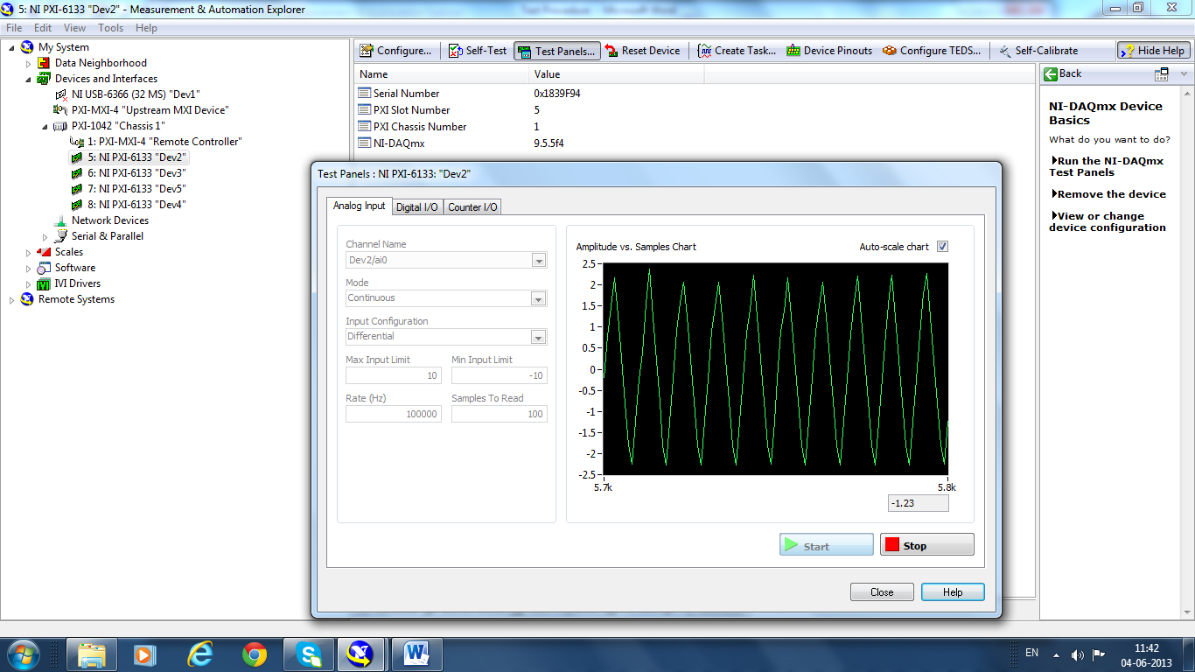

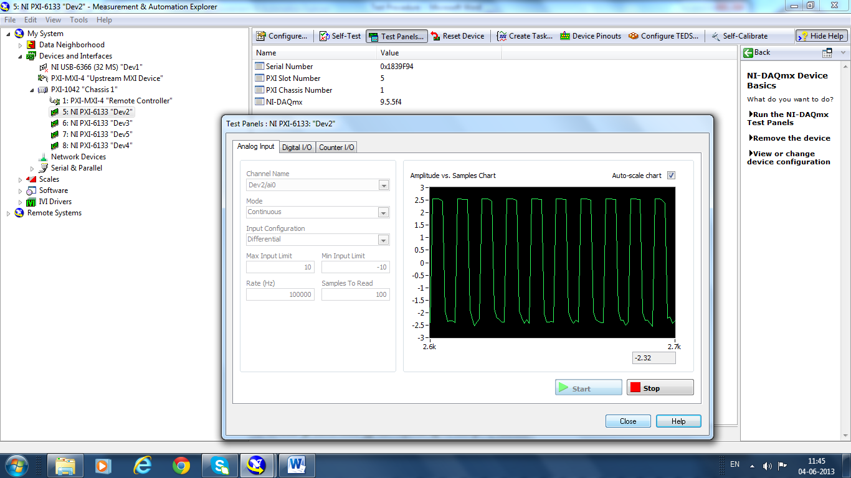

So the modules connected with the chassis PXI-1042 are:
- PXI-MXI-4 Remote controller
- NI-PXI-6133 “Device 2”,
- NI-PXI-6133 “Device 3”,
- NI-PXI-6133 “Device 4”,
- NI-PXI-6133 “Device 5”.
- Run Test LabVIEW program

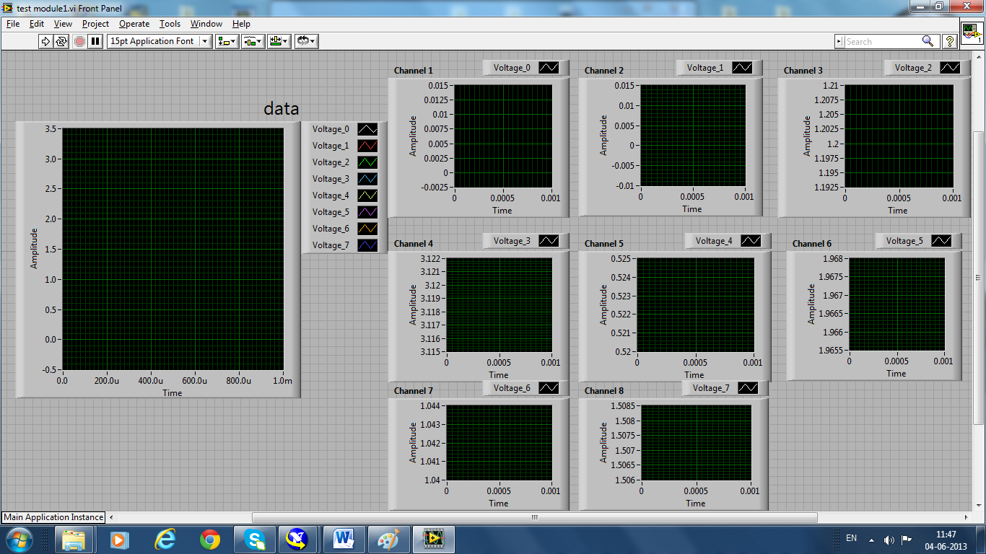

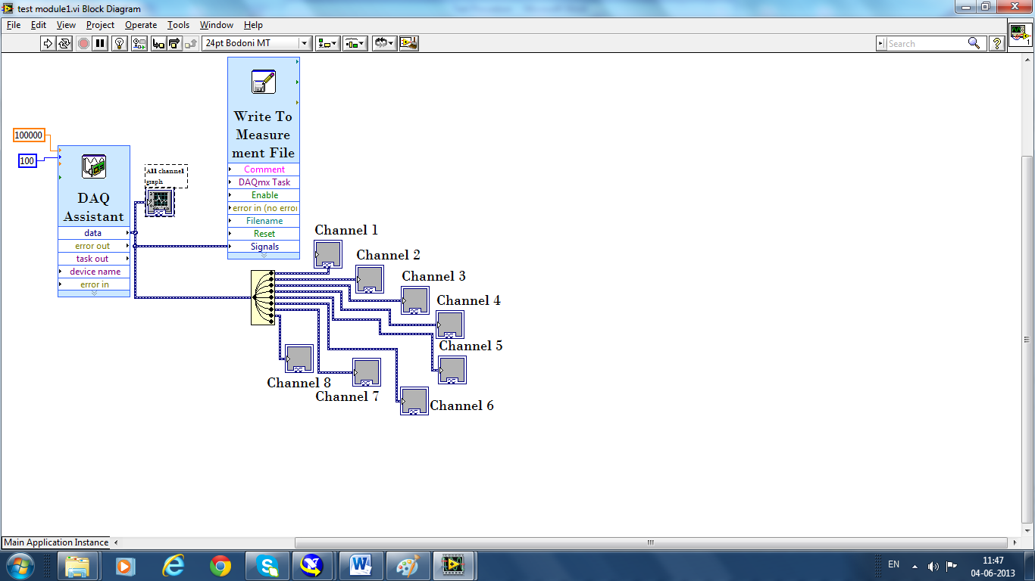

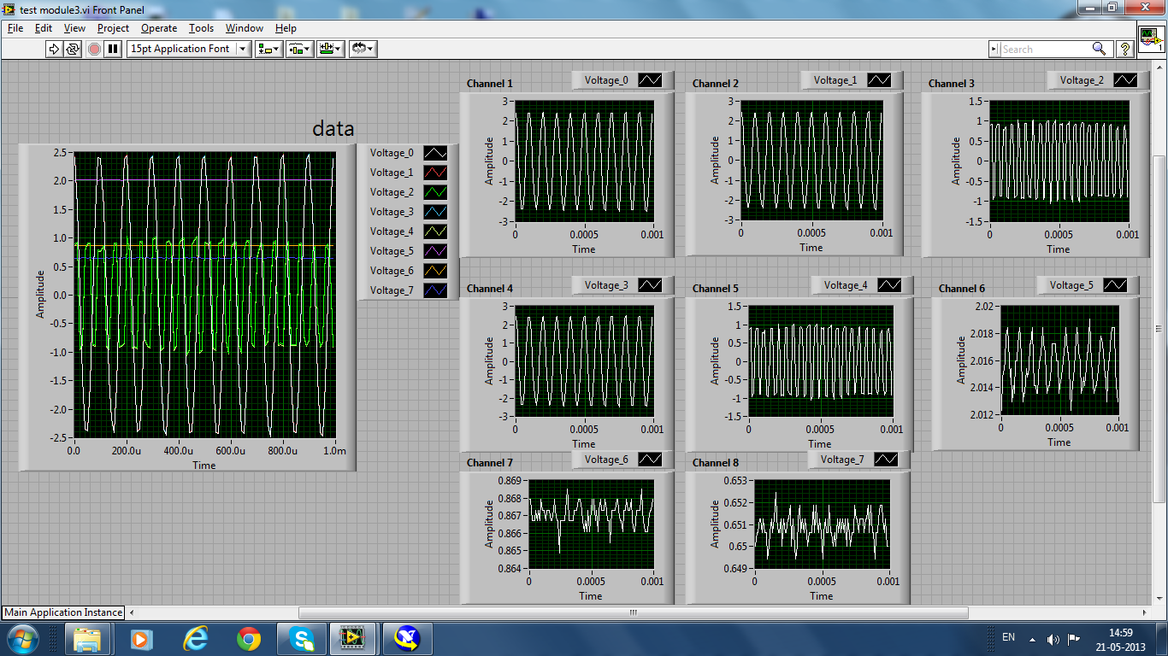

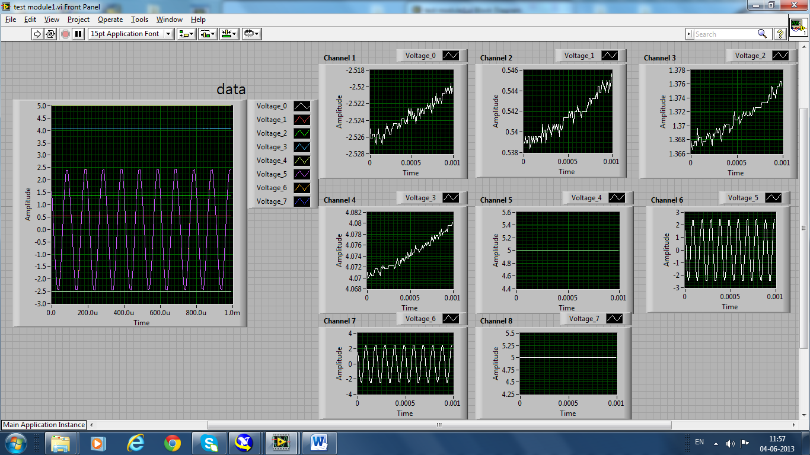
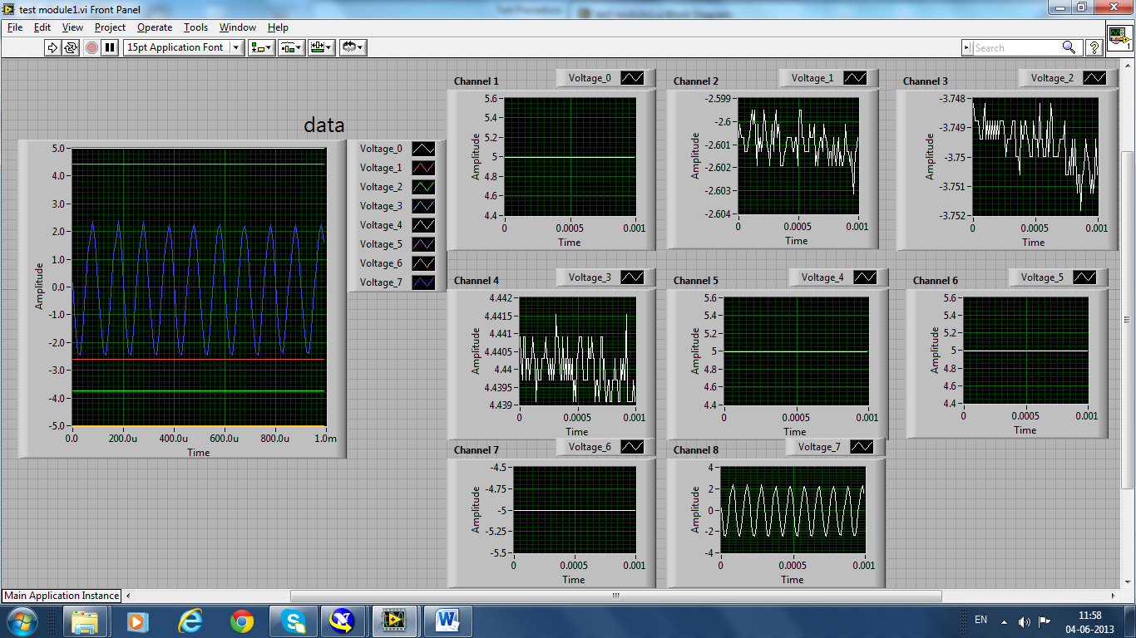

Block Diagram
